GOOD NEWS REALTY
45 Airport Road, Indiana, PA 15701
$650,000

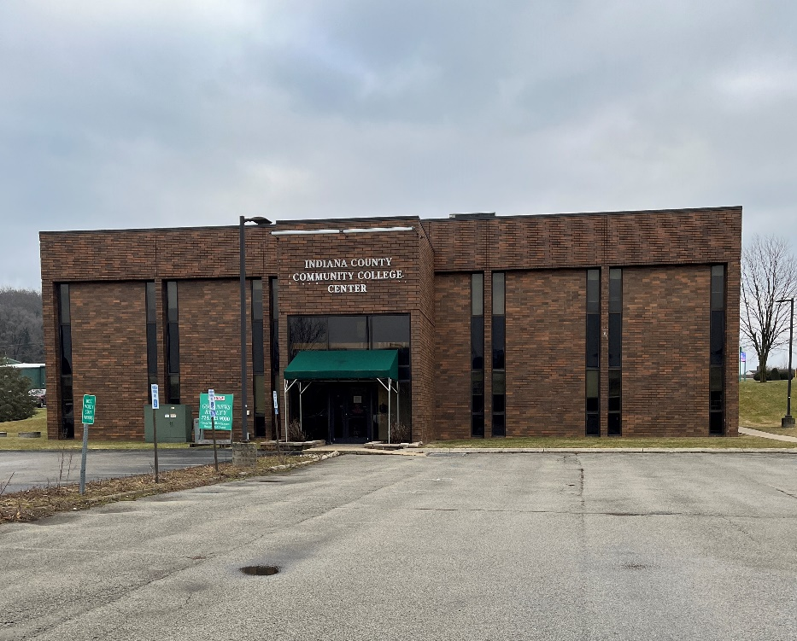
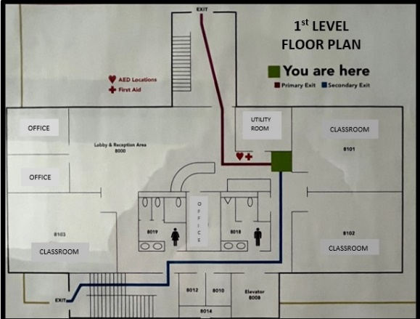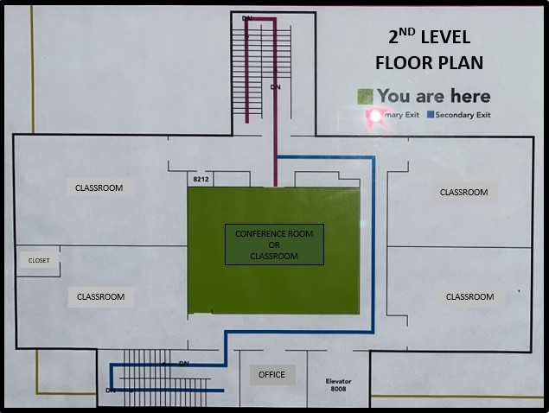
Office/Educational Building - Most recently used as an educational/training facility. Quality, brick construction. Clean and very well maintained. The main level features a spacious entrance lobby, three offices, two restrooms, 3 large rooms, and utility room. The second level features four large rooms, one office, and a large multi-purpose/conference room. The room layouts can be redesigned and altered. The second floor is accessible via 2 staircases or an elevator. Located at the Indiana Airport Professional Center complex that provides ample parking. When considering the cost of new construction, this is a bargain for $650,000.
Parcel Number: 42-011-148.10A1 Lot Size: 1.59 acres
Municipality: White Township School District: Indiana
Year Built: 1992 Parking: Off Street
Assessed Value: $516,800 Annual Tax: $10,534
Heat: Gas Rooftop Unit Air: 3 Central Air Units
Water: Public Sewage: Sand Mound

GOOD NEWS REALTY – 724-463-9000

